Homework Set 2

**Problem 1**

(a)

Degree 1 polynomial has training error 6.54

Degree 2 polynomial has training error 0.72

Degree 3 polynomial has training error 0.06

(b)

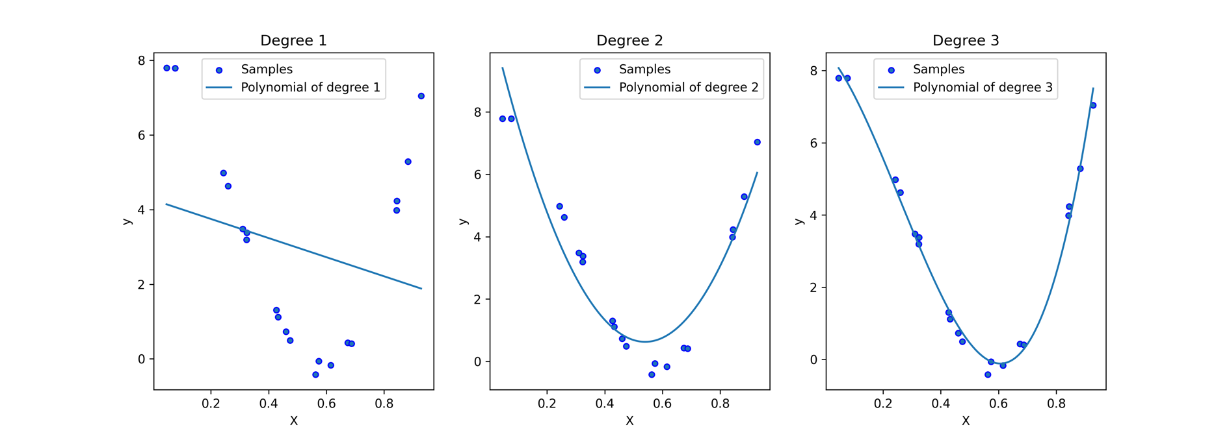

**Problem 2**